

Welcome to the 2023
From Harvest to House Gathering
September 12th, 2023 to September 13th, 2023

Foreword

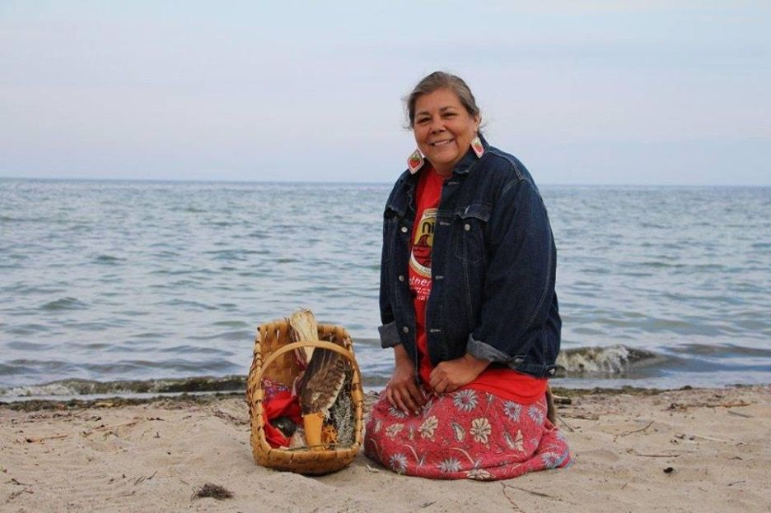
Tansi, Ahnii boozhoo, Greetings my friends,
It is an immense k’chi pleasure to be with you as this is an important step in a journey I only dreamed about a few years ago.
Let me introduce myself properly to you. Becky Big Canoe n’dizhnikaaz, miinwa NgigKwey, miinwa NgaajigoKwey, miinwa ManidomateshingKwey. I am simply a woman, Georgina Island n’doonjibaa, who has a belief and a will, gifts I fostered from the Creation. Ngig n’dodem, Waabsheshii miinwa. AnishinaabeKwey n’daaw.
I have little education or career but a knowing and a strong belief that one of the most damaging of the colonial programs of disempowering us, was to take from us the ability and the agency to build and furnish our own homes. And to promise us a welfare state as a replacement. When I had the opportunity to build a home I chose to use the straw bale method for cost, energy efficiency and just because I like to do things the way I choose to do them. Over twenty years later, my house is still solid, remains mold free and both warm in winter and cooler in the summer heat.

In those years, I chose to become an advocate for more sensible options in housing and that has led me on this journey where I became connected with the Reconciliation through Engineering program at the University of Toronto. I would like to extend my sincere gratitude to all of the members of that awesome team for forging forth into this difficult field of the housing crisis that exists across our homelands. I hope that the work that is done between them and the members of the communities proves to be helpful and effective for now and for future generations. I believe we must take this issue into our own hands and seek solutions that work for us because it is us that knows what we need.
I look forward to all of the activities and really hope to personally meet you and talk to you about all of the possibilities that this opportunity presents.

Miigwech wi
Becky Big Canoe

Mental Health Services
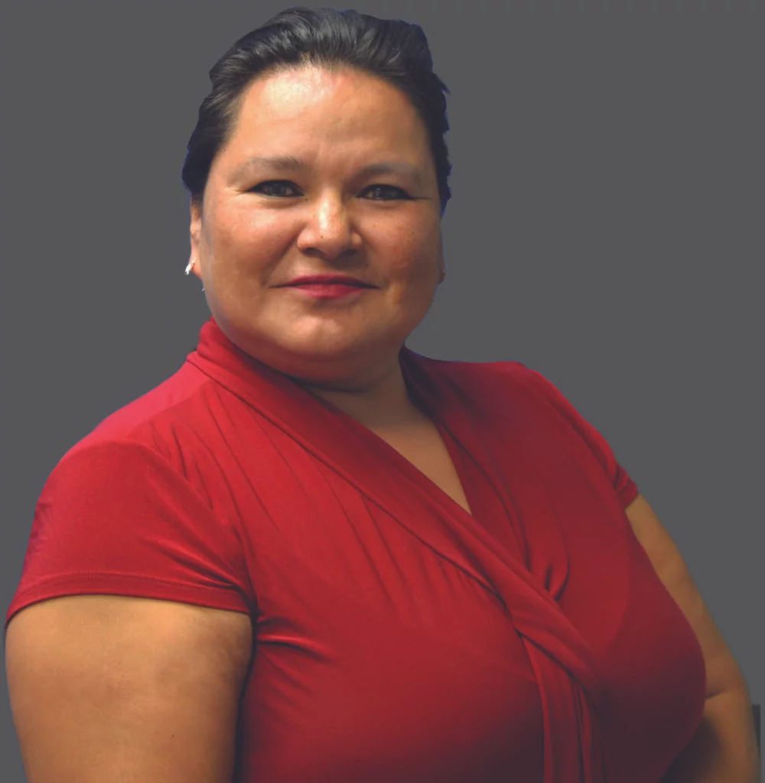
Maxine Ballantyne, Mental Health Professional - Indigenous Holistic Therapy
https://ihtherapy.ca/about-me/
Expertise and specialities: Narrative therapy, inner child healing, grief and loss, crisis intervention, addictions therapy, crisis intervention, suicide intervention

Mental health services will be provided throughout the event, please flag a team member or Maxine if you would like her professional services. The Spadina Boardroom has been reserved for moments of reflection and mental health service. In
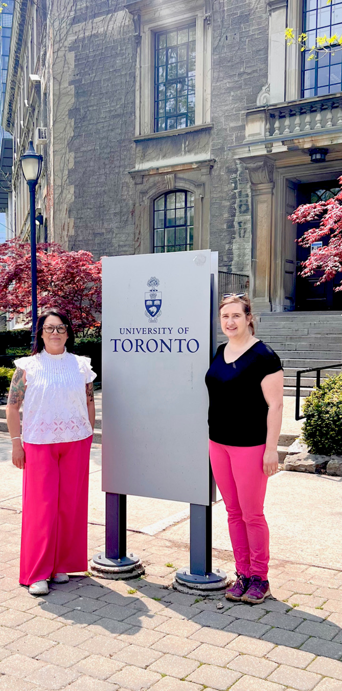
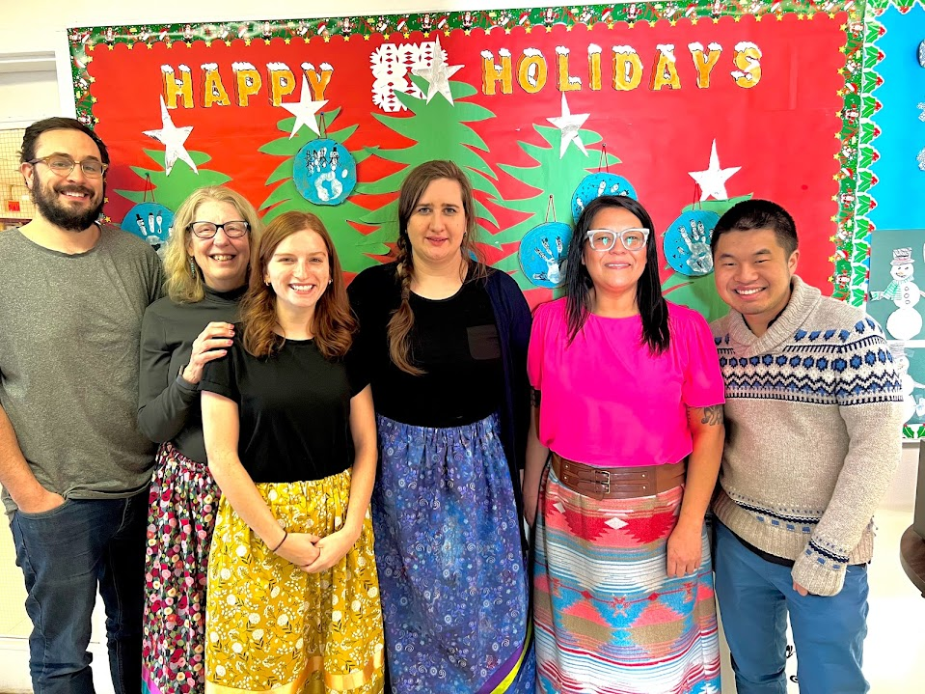

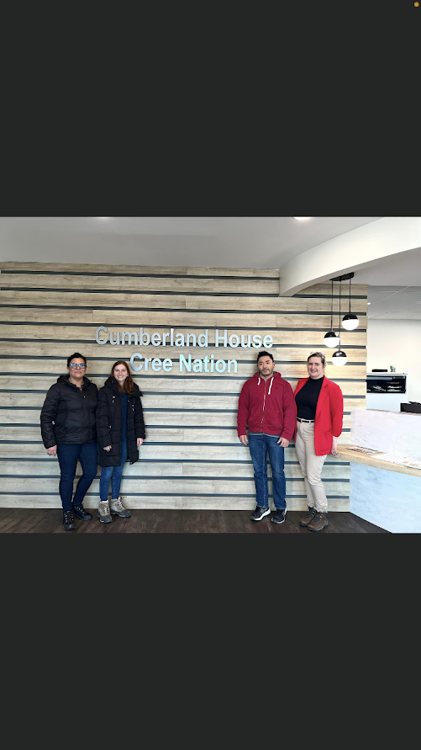
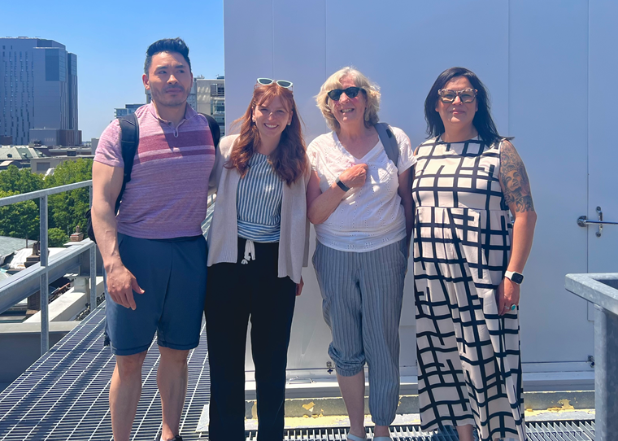

Schedule
Day 1
All events will be located in the Battleford Room
08:00AM - 09:00AM Breakfast (including sign in)
09:00AM - 10:00AM Workshop Introduction
10:00AM - 10:15AM Coffee Break
10:15AM - 12:00PM Storytelling Activity
12:00PM - 01:30PM Lunch
01:30PM - 02:30PM Storytelling Activity Continued
02:30PM - 02:45PM Coffee Break
02:45PM - 04:30PM Air Filter Activity
04:30PM - 04:45PM Closing Remarks
05:00PM - 07:00PM Dinner
Day 2
All events will be located in the Battleford Room
08:00AM - 09:00AM Breakfast
09:00AM - 09:15AM Day Introduction
09:15AM - 09:45AM Rich Pictures Activity Introduction
09:45AM - 10:00AM Coffee Break
10:00AM - 12:00PM Rich Pictures Activity
12:00PM - 01:30PM Lunch
01:30PM - 02:45PM Panel Discussion
02:45PM - 03:30PM Moving Forward Discussion
03:30PM - 04:00PM Closing Remarks

Program Activities
Storytelling Activity - Day 1
Why are we telling stories?

We are all here because we have some stake in housing and creating homes. We all come from different backgrounds, from different communities and from different spaces with different experiences of what “home” is and means to us. We bring shared experiences and interests as well as starkly different experiences and priorities. That gives us a wealth of resources we can use to figure out how to create better solutions for houses and homes.

We are going to build some common ground to begin with by sharing little stories about what “home” means to each of us. We start with the idea of “home” because we want to start with a goal. Whatever plans, strategies, goals, actions we decide to take in the course of these workshops should contribute to building that sense of home that we each have and value.

We all tell stories, we all listen to stories. I think we all like to both tell and listen to stories, so that is how we will begin. Our stories show what is sometimes challenging to explain - sort of the difference between describing something and showing someone a picture. Our stories are more like pictures than descriptions.

If any of you are like me, one story can lead to another story and to another and I sometimes forget which story I started to tell. Because we only have these two short days and many things to accomplish, we all need to be careful about time so we are going to set some limits on this first set of stories so that everyone gets to both tell and listen to the stories.

The process we will follow:

- We will work in groups of 3 or 4 - Group numbers are on back of name tags
- Start by introducing your name and affiliation
- Each person will have 3 minutes to tell your story to the others in your group.
- Every 15 minutes we will change groups.
- We will repeat this process with a different story prompt. You will tell two stories during this activity.
- After lunch, regroup with your initial table and share what you heard that was similar and different from your own experiences.
- What do these similarities and differences make you think about?

We will need to be very strict about time limits so that no one has to rush their story or gets left out at the end of a round!

One person in each group needs to take charge of making sure EVERYONE in the group gets their 3 minutes. Somebody from the workshop team will signal when it is time to move to the next group.

You will tell each story 2 times. It will probably be a little different each time and that is just fine because you are telling it to a different group of people. Each time you tell something you also remember a little bit more or different things become more vivid. Stories live in the telling.

Prompt 1: What does home mean to you?

Prompt 2: What have you been faced with that either supports or frustrates/gets in the way of your experience and feelings of home?

Air Filter Activity - Day 1
What is particulate matter (PM)?
- Particulate matter is any solids or liquids in the air
- Different compositions (can contain organic molecules, contain viruses, bacteria, heavy metals, etc.)
- Categorized by size: PM₁₀, PM_{2.5} and UFP
- Has long-term and short-term health effects:
      - short term: headache, fatigue, sore throat, asthma exacerbation, potential cognitive impacts
      - long term: COPD worsening, cardiac impacts, increased mortality on high PM days
- Who is most at risk: COPD, asthma, cardiac and respiratory health issues
- Comes from indoor sources like: cooking, burning anything (candles, etc.), walking/resuspending dust, breathing, fireplace, wood-burning oven, essential oil diffuser, respiratory particles
- Outdoor sources include: wildfires, traffic emissions, refineries, and pollen
- Sometimes sources are essential, so using an air cleaner and/or ventilation can help

When and how should we use air cleaners?
- Use air cleaners when there are sources of particulate matter (described above)
- Use when gathering indoors with many people to avoid airborne disease transmission
- Close windows and run air cleaner for better performance
- Place air cleaner near the source of particulate matter or near the protected individual(s)
- Air cleaner use can help with asthma symptoms and allergies associated with airborne allergens (pollen, pets, etc.)
- This air cleaner doesn’t remove gas pollutants like carbon monoxide, VOCs, and radon
- Choose a filter with a high MERV rating (11-13)
- Change the filter approximately every 4 months or when dirty

Rich Pictures Activity - Day 2
Creating “Rich Pictures”
(The first rule of “rich pictures” - no drawing or artistic skill required!!)

“Rich Pictures” refers to an approach groups of people often use to get a better understanding of complex, messy problems. Messy problems are messy because they have lots of competing interests, perspectives, and approaches to solving the problems. When a group builds a fuller understanding, including understanding of how the parts of the problem are tangled together, that fuller understanding can start thinking around new approaches, different potential resources, partnerships or strategies.

We will use “Rich Pictures” to map out a richer understanding of the housing situation as you experience it in your context in your community. Depending on your past experiences, your position in the community, your responsibilities in the community you will have different experiences and perspectives. It is important to show all of these.

The focus is on pictures and images; showing rather than explaining and describing with words. We know that images and pictures can often show us much more than words alone so we want to start with images. Stick figures, boxes, circles, arrows and lines—that is really all you need. No one needs to be an artist to do this!

EVERYONE participates. You don’t have to wait your turn. We use big pieces of paper so that everyone can draw at the same time. And you can make the pieces of paper as big as you wish because you have tape. We have more than enough pens and markers for everyone to use multiple colours. You don’t need to wait your turn to add to the picture. Everyone can draw (and talk) at the same time. It is often quiet at the beginning as people are thinking and drawing. But it doesn’t usually stay quiet. People start to ask questions and talk and laugh.

Every group will have approximately 45 minutes to complete their picture

The process we will follow:
- Take a few quiet minutes to think about the housing situation in your community. What does it look like?
- Choose any section of the paper to begin drawing, sketching, representing your view of the situation.
- Draw the housing situation in your community as you see and experience it.
- Draw yourself in the situation.
- Draw all that you perceive (feel, see, hear).
- Include structures, processes, relationships, objects, people.
- Use whatever symbols, pictures, colours, lines, shapes you want.
- Try to limit the use of written words/explanations.
- Each group will “present” their picture to the whole group (hold question and comment until each group has presented).
- Display the pictures so everyone can look at (and admire) them.

This is NOT an art project. The goal is to create as complete a picture as possible that you can use to understand the situation more fully and use it to identify where you may want to focus.

Panel Discussion - Day 2
We have gathered four panelists with expertise in housing training, architecture and energy to discuss challenges and pathways forward for housing in your community. Please bring your questions so that we can strengthen and build these connections.
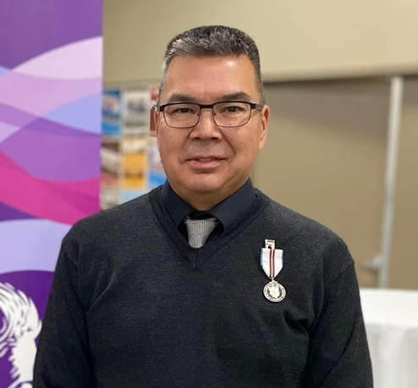
Geoff Despins
Prince Albert Grand Council – Urban Services Director
Email Gdespins@pagc.net
Website: www.pagc.Sk.ca
1-306-765-5300

For more Information on
SITAG - Saskatchewan Indian Trading Assessment Group Inc.
Saskatoon: 1-306-477-9337 Email: sitagadmin@sitag.ca
Website: https://sitag.ca/
PAGC Urban Services Director Geoff Despins joined the Prince Albert Grand Council – Urban Services in 2002 as a Youth Employment Coordinator. Over his 21 years he served in various positions as a Labourer Force Development Coordinator and Partnership Coordinator before taking the position as the Director of PAGC – Urban Services. Employment and Training for Prince Albert Urban members. would utilize a combination of leadership, employment, and academic background, as well as personal qualities and characteristics, to seek employment in enhancing positive community relations and services for First Nations peoples.
Within the city of Prince Albert and PAGC Communities our mandate is to research, develop, implement, and promote employability, reduce criminal rate and criminal behavior. Encourage positive and healthy family dynamics by providing the necessary resources and support to families. Educate, inform, and promote traffic safety. Positively engage our youth by highlighting programming in the sports, culture and recreation area.
Geoff Despins is a member of the Lac La Ronge Indian Band. He resides in Prince Albert, SK.
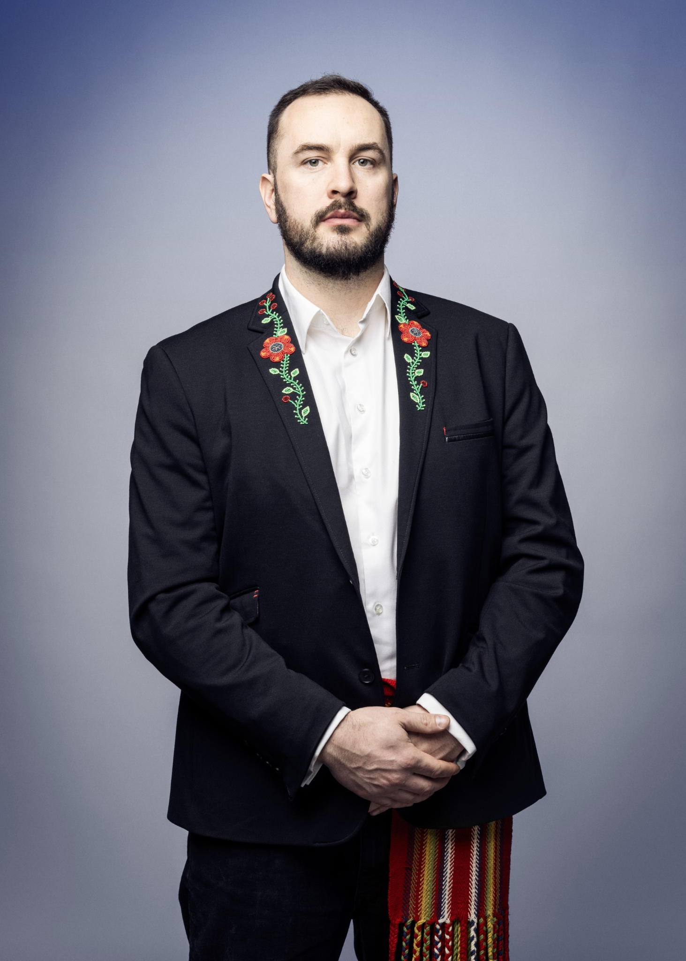
Jason Surkan
Architect SAA, AIBC, B.A.S, M.Arch., MRAIC
Born and raised near Kistapinânihk/Prince Albert, Saskatchewan, Jason Surkan is a son, grandson, great-grandson, father, step-father, uncle, and brother. His maternal family ties are from the Red River Métis community. Jason is a registered member of the Métis Nation of Saskatchewan. He holds a Bachelor of Architectural Studies (B.A.S. 2016) from Carleton University and a Masters of Architecture (M.Arch. 2018) from the University of Manitoba. Jason also studied at the University of Saskatchewan and the University of British Columbia. Jason has studied under Pritzker Architecture Prize-winning Architect, Glenn Murcutt. During his time in Ottawa, Jason worked for Indigenous Architect, Douglas Cardinal on both a professional and cultural level. He has also worked with Oxbow Architecture and David T Fortin Architect. Jason is a member of the RAIC’s Indigenous Task Force in Architecture.

Moving Forward Discussion - Day 2
Thank you for participating in our 2-day event. We hope that you have enjoyed and learned as you participated in these activities. These activities are meant to be the starting point in working together to address issues that present challenges to your efforts to create sustainable housing.

Where can you start? What can you take back to your community? What do you want to accomplish with other members of your community? How do you want to share what you have learned? You can start to answer these questions using what you have learned here with other community members. What have you identified as something you could start with? It can be something as simple as holding discussions within your community about your housing experiences/plans for the future or putting together a “how to” manual for simple home repairs (including how to source washers or lightbulbs).

Now is the time to use all the resources you have here and put together a plan for what you will do once you return to your communities. For our part we will be looking through all the insights and information you have provided through your stories, your observations, your Rich Pictures, your discussions and your questions and will provide you with summaries in mid-October or early November. We would encourage you to share your own progress and frustrations with each other and with us. It is likely that together, in collaboration, we can be more successful than working in isolation.

Write down your plan, your steps, your strategies. This is a living plan that can and should change as your circumstances change.

Team Introduction
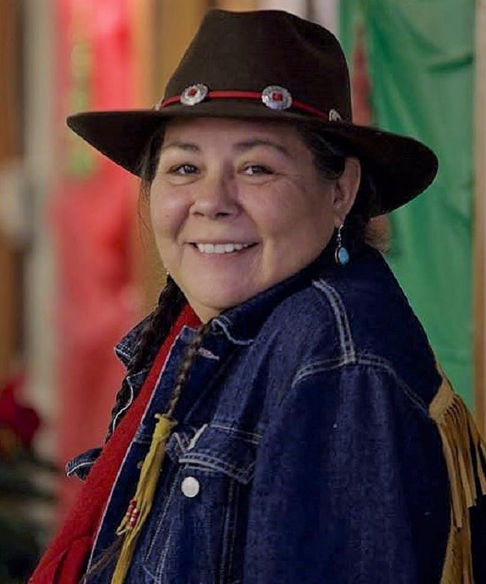
Becky Big Canoe, Elder
Founder, EnviroNative
Interests and expertise: Local materials, training, local housing, sustainable buildings, land trusts

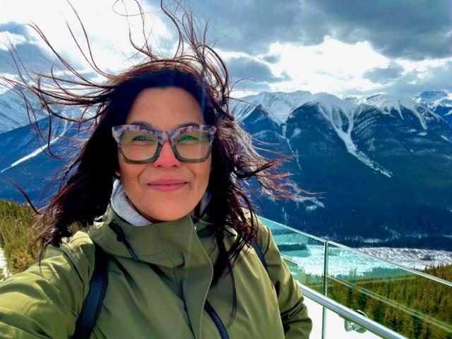
Natalie Clyke, Executive Director - Rocktree MgO Construction Material Inc
house1sask@gmail.com https://house1solutions.my.canva.site/rocktree
Interests and expertise: Housing Management and Infrastructure, Mould & Fire Resistant Building Materials, Community Housing Models, Homelessness Advocate - Shelter Development, Property Management.

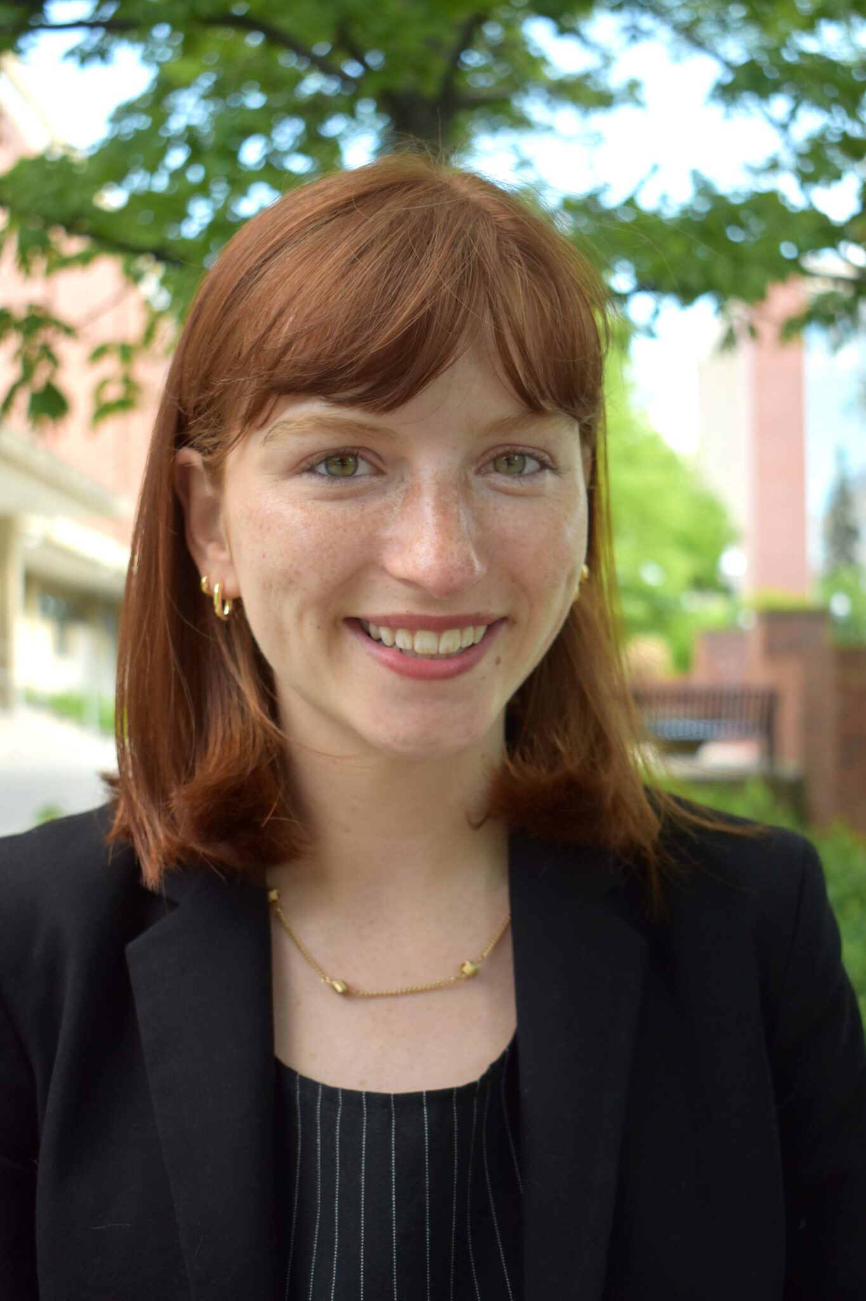
Dr. Sarah Haines
Assistant Professor, Department of Civil & Mineral Engineering, University of Toronto
s.haines@utoronto.ca
Interests and expertise: Indoor environmental quality, mould, moisture, viral transport, microbial emissions

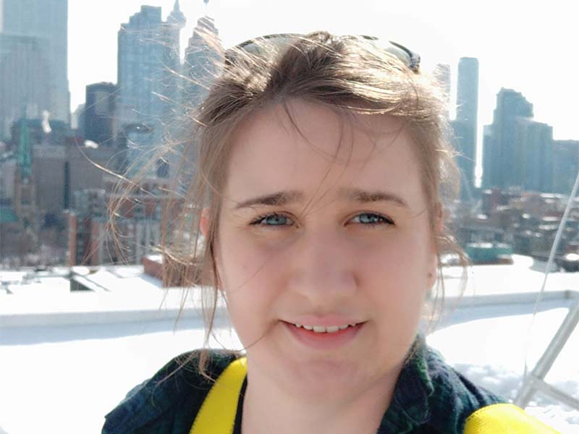
Dr. Helen Stopps
Assistant Professor, Department of Architectural Science, Toronto Metropolitan University
hstopps@torontomu.ca
Interests and expertise: Building science, building energy use and indoor conditions, building operation & HVAC, social sustainability, data-driven building modeling

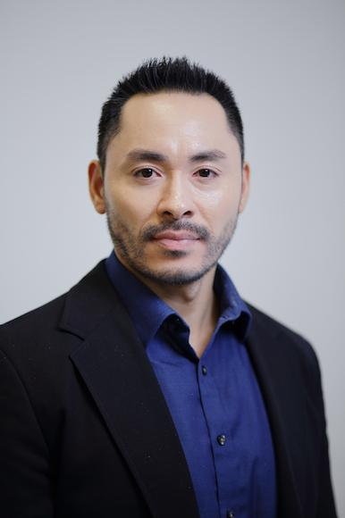
Dr. Nicholas Spence
Assistant Professor, Department of Health and Society, University of Toronto
nicholas.spence@utoronto.ca
Interests and expertise: Social inequality, social and psychosocial determinants of health and well-being, interdisciplinary research, policy, chronic and infectious disease, pandemics, obesity, gene-environment interactions, mental health, addictions, stress, safe water, climate change, economic development, education, labor markets, Indigenous Peoples.

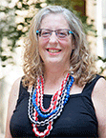
Dr. Penny Kinnear
Instructor, Troost Institute for Leadership Education in Engineering, University of Toronto
penny.kinnear@utoronto.ca
Interests and expertise: How students make meaning in team contexts, telling stories, professional identity development and the impact of multilingualism and translingualism on the ecology of university classrooms.

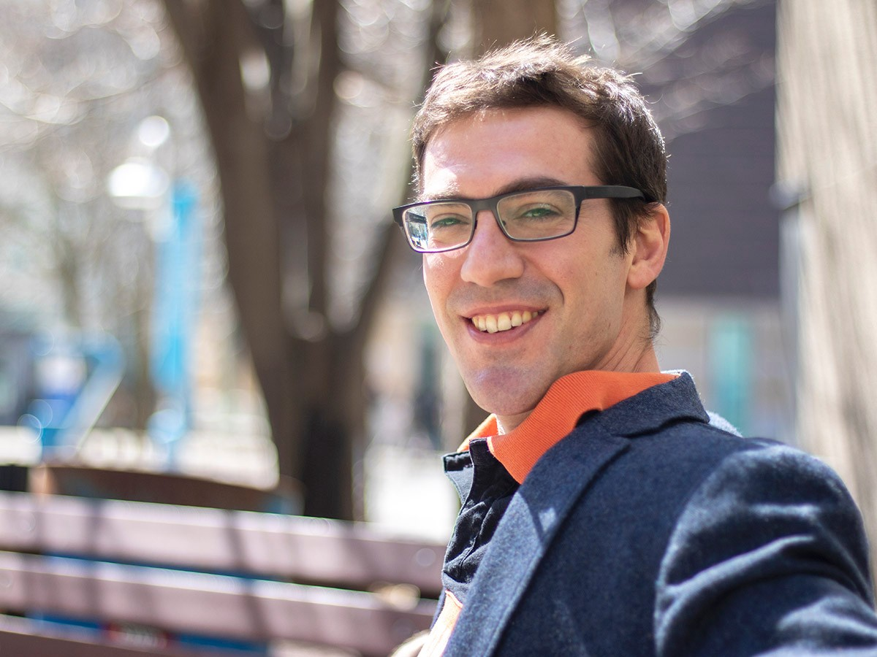
Dr. Russell Richman
Professor & Associate Chair, Graduate Studies, Building Science, Toronto Metropolitan University
richman@torontomu.ca
Interests and expertise: Building science, building envelope, material analysis, passive house standards & sustainable retrofits

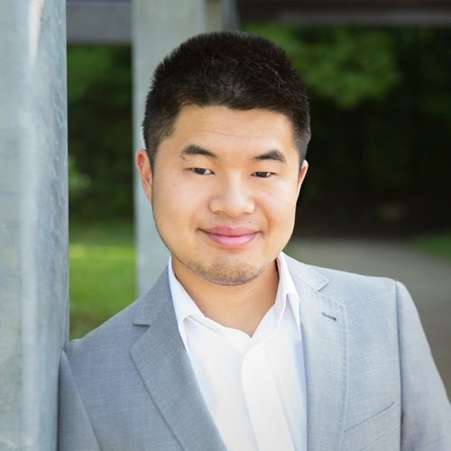
Michael Wong
Master’s Student, Architectural and Building Sciences/Technology, Toronto Metropolitan University
michael.d.wong@torontomu.ca
Interests and expertise: Green buildings, sustainable design, low-carbon technologies

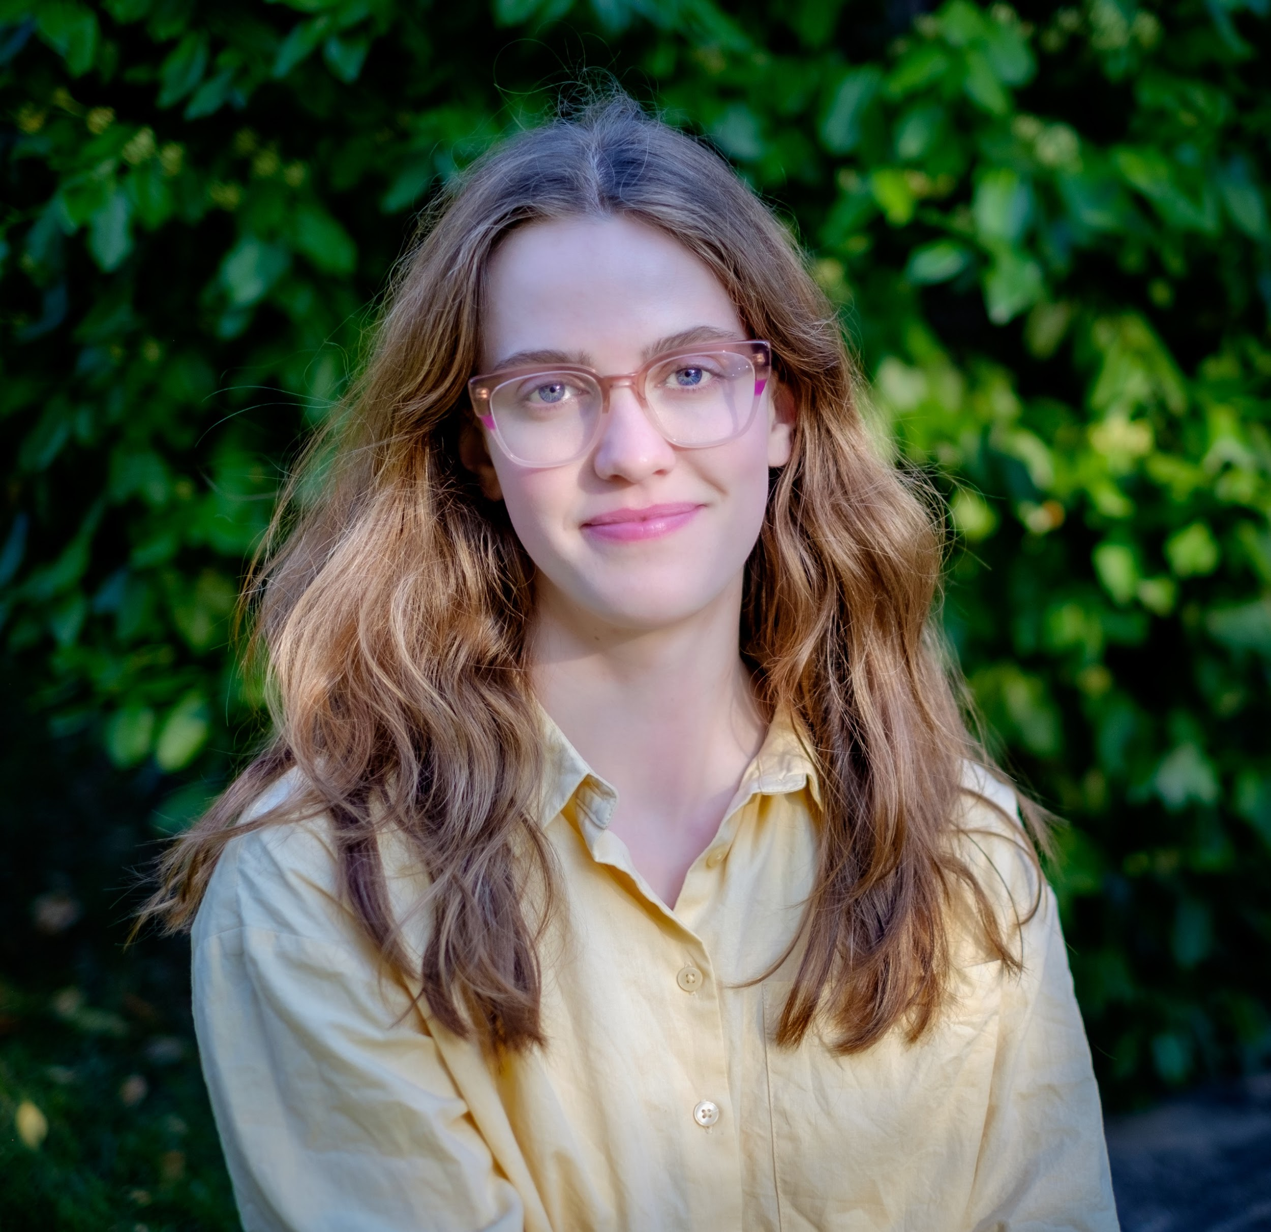
Zoe Hoskin
PhD Student, Department of Civil & Mineral Engineering, University of Toronto
zoe.hoskin@mail.utoronto.ca
Interests and expertise: Indoor air quality (IAQ), ventilation, filtration, air cleaning, indoor airborne disease transmission, indoor airborne SARS-CoV-2 concentrations, sustainable buildings, air quality in schools

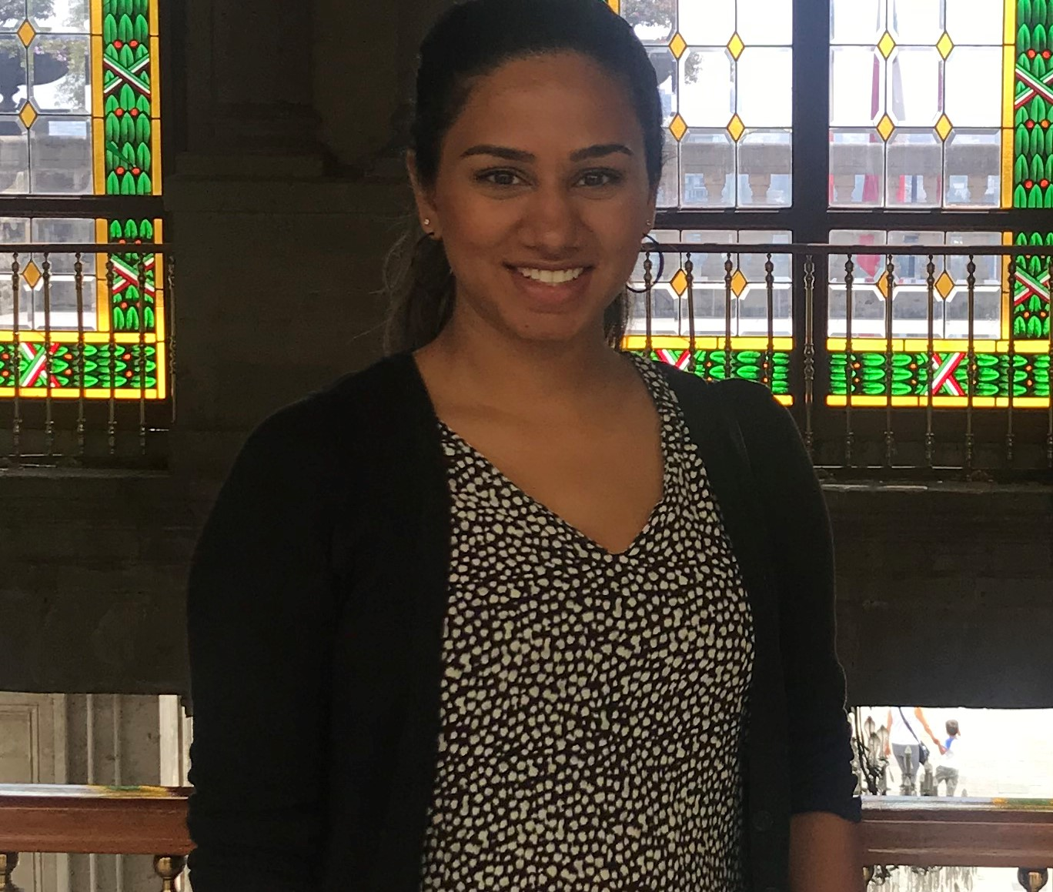
Fatima Ahmed
PhD Candidate, Environmental Science, University of Toronto
fa.ahmed@utoronto.ca
Interests and expertise: Community-based research, land-based programs, well-being, youth engagement, pandemic planning

This workshop was funded through the University of Toronto Connaught Global Challenge Award, Toronto Metropolitan University Faculty of Engineering and Architectural Science Dean’s Research Fund, and SSHRC Connections program.




Contact Information
Website: https://fromharvest2house.ca
For additional information please contact: house1sask@gmail.com
For travel reimbursement questions please address emails to Michael Wong michael.d.wong@torontomu.ca

Notes

